
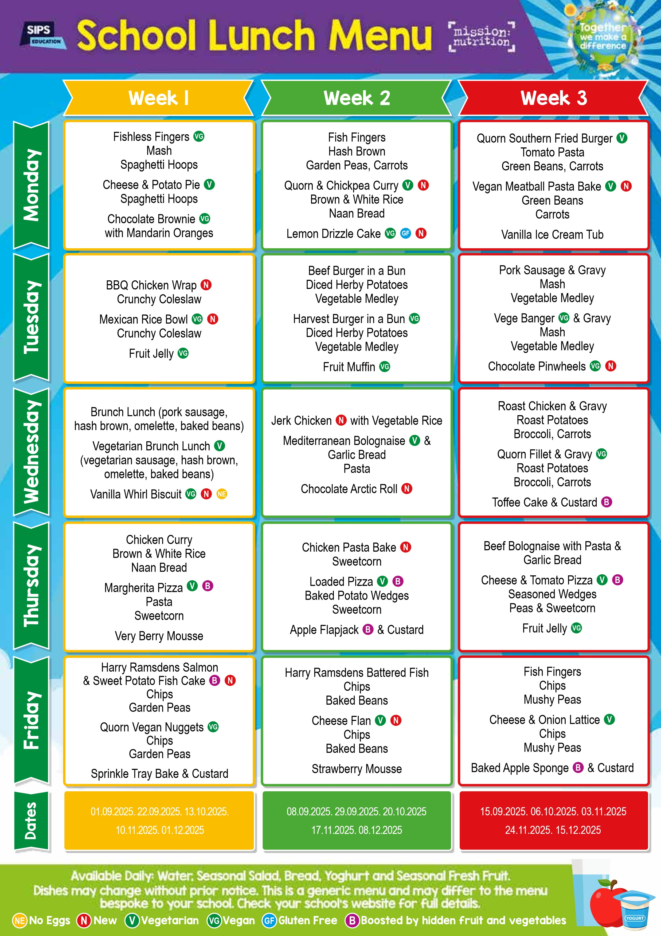
19/01/2026
12/01/2026
05/01/2026
26/01/2026

